North Dakota
HOSA-Future Health Professionals Organization

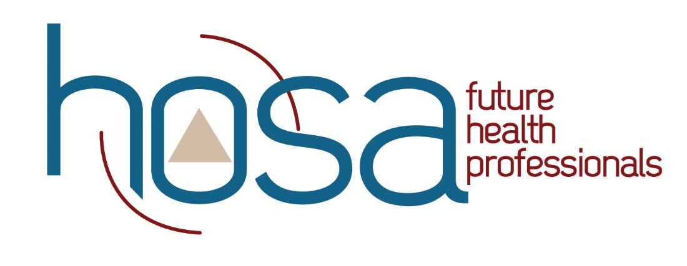

2023-2024 Member Packet

Table of Contents

Welcome Letter........................................................3

About HOSA...............................................................4

State Officers………………………………..................4

Social Media...............................................................5

Website........................................................................5

Conferences................................................................6

Dress Code..................................................................7

Competitions………………........................................8

A Letter from the State Officer Team
North Dakota HOSA-Future Health Professionals
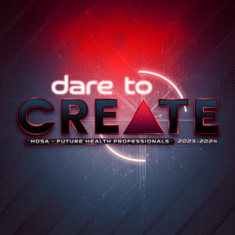

North Dakota HOSA – Future Health Professionals is the premier student organization for students pursuing careers in healthcare. The doors opened, opportunities experienced, and leadership development that takes place through this healthcare focused student organization is second to none.
-Brandy Madrigal, North Dakota HOSA State Advisor
brandy.madrigal@mayvillestate.edu

On behalf of the entire State Officer team, we would like to say, “Welcome!” The state officers are working incredibly hard to make sure that your interest will one day help you on a path to achieve your dreams! Being a part of this amazing organization will not only help you affirm your passion for the medical world, it can also help build new friendships and connections to last a lifetime.

We are planning to take ND HOSA to a new level this year, and we need your help! We continue to set new goals like increasing our membership but more importantly, our impact on future health professionals throughout North Dakota and the nation. Your commitment to a productive local chapter strengthens the effect our student organization can have on the entire state, and beyond. How can you help? Everyone within this organization plays a vital role in making sure ND HOSA continues to provide our members with incredible opportunities while offering aid and support to our communities.

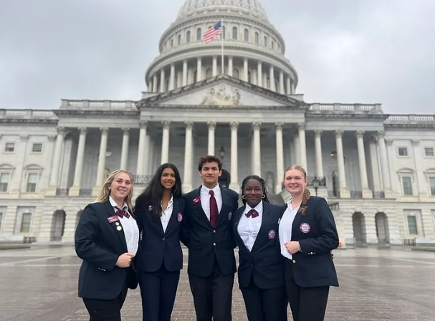
This year's National HOSA theme is “Dare to Create”. As you work with your local chapter to identify your local program of work details, consider ways you can step beyond your comfort zone to try new things, meet new people, and work hard to exceed any limitations you set for yourself. Believe in yourself, you can absolutely accomplish whatever you put your mind to. A little bit of hard work now can have a significant impact on the rest of your future. Join us as we strive to go, “beyond all limits” with North Dakota HOSA this school year!

Respectfully,
State Officer team

What is HOSA?
HOSA-Future Health Professionals (most often referred to as “HOSA”) is a career and technical student organization (CTSO) specifically dedicated to preparing students for careers in the health science cluster. It is the only student organization that is 100% healthcare based, including fields from biomedical laboratory science, dental science, pathophysiology, medical photography, and even veterinary science. Being a part of HOSA helps to develop leadership skills like teamwork and communication. This organization gives members the opportunity to become chapter officers, state officers, and possibly elected to the National Executive Committee.

Founded in 1976, HOSA now has over 4,500 middle school, secondary, and postsecondary/ collegiate chapters in 54 US states and territories, Canada, Mexico, Italy, and Germany, serving over 225,000 active members. North Dakota HOSA began in the academic year 2012-2013 and has grown significantly through the years.
A way to develop skills is by participating in competitive events to refine leadership and professional competences. HOSA currently has a selection of over 40 competitive events for members to choose from. The events are distributed into 5 categories: Leadership, Health Science, Teamwork, Emergency Preparedness, and Recognition events. These events are geared towards providing a broad range of experiences to members.

Who are the State Officers?
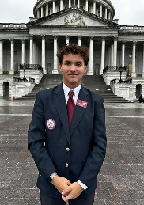
North Dakota State Officers have been elected to uphold the highest level of responsibility and dedication to ND HOSA. State officers are elected to help guide and govern this organization with our delegated responsibilities. Currently serving as your 2023- 2024 State officers are:
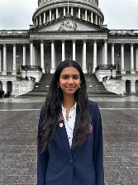
President - KYAN WOODRUFF
(Email- NDHOSA.President@outlook.com)
Vice-President
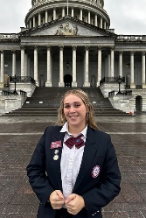
ABHIJNA KAVASSERi

ASPEN SCHROEDER
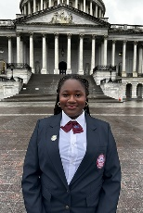
Social Media/Historian
BLOSSOM EHIGBIBE
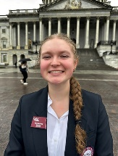
MOOREA KNAPP Community Service Secretary Coordinator

Do you have any social media information?

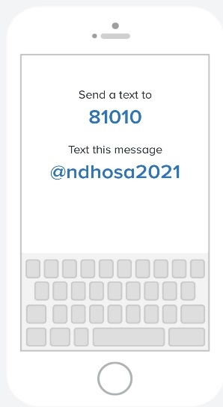
Social media is a quick and effective way for important announcements and information to be spread throughout the state. We strongly encourage every member within the state to follow and become actively engaged with our social media platforms to stay informed.
Our social media handles are:

Instagram- NDHOSA

Facebook- NorthDakotaHOSA

Remind- This text message platform will become the most beneficial to members throughout the year. If you only use one, we strongly encourage it to be this one.

What about a website?
ND HOSA has recently created a new and improved website that is more user friendly and easier to navigate. We hope that every member uses this tool to help further student engagement. Follow the steps below for more information about using the new website.

www.ndhosa.org
After searching the above website, this page should pop up:
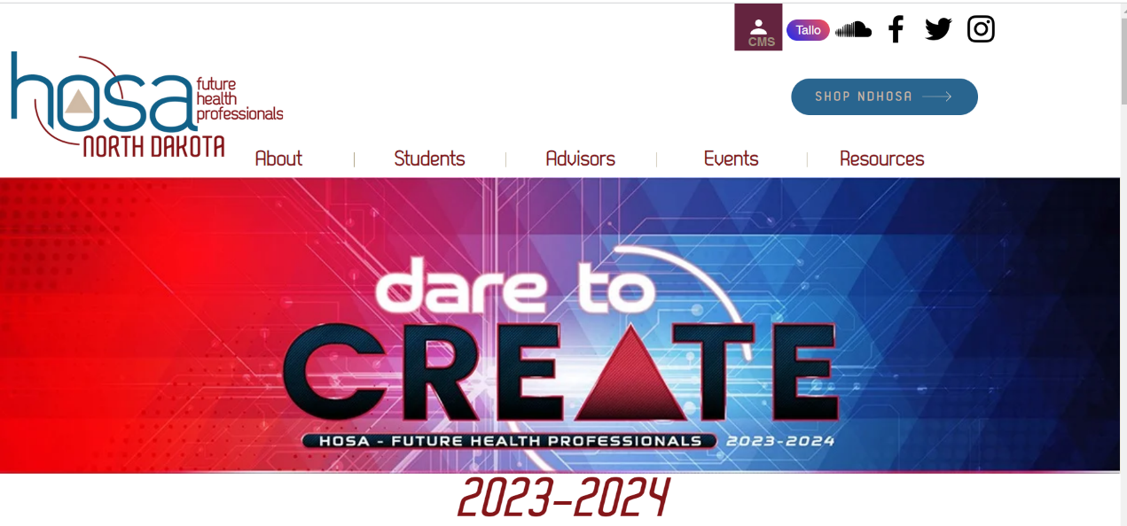
Clicking the topics at the top of the page will enable us to use the website more effectively. Choosing either the Students tab or Resources tab will give you the most information about the happenings.

When do we get together?

Every year HOSA- Future Health Professionals holds two conferences for the State: , those
- Fall Leadership Conference (FLC) held in October or November
- State Leadership Conference (SLC) held in March or April

FLC is not a competitive conference. FLC introduces local HOSA members to meet the state officer team, attend workshops, participate in educational lessons, strengthen team bonds, and listen to a keynote speaker. This is typically a one-day event due to distances traveled throughout the state.

SLC is a competitive conference. Using the knowledge and skills learned throughout the school year, HOSA members have opportunities to compete in individual and team contests focused in various areas of interest. SLC also features workshops, large general sessions, keynote speakers, and an award ceremony.

State officers also attend extra conferences to help build upon their knowledge this would include:
- HOSA Washington Leadership Academy
- CTSO Training (state officers training)

What should I wear?

One of the most frequently asked questions about HOSA is the dress code. We will do our best to include dress code expectations for the various gatherings. For FLC, it is expected that the State HOSA Officer Team is in what is called “HOSA Casual,” where they wear khaki pants with their maroon HOSA polo shirt. Other HOSA members are expected to wear “business casual,” which suggests comfortable pants that do not have holes, blouses, sweaters, button-downs, or polo shirts, knee-length or longer dresses, closed-toe shoes, and simple accessories. Dark jeans are acceptable, provided there are no holes, stains, or visible areas of wear. Remember, we want to be seen as “professionals” even in casual apparel.

For SLC, the official HOSA uniform will be expected at opening and closing sessions, as well as some competitive events. Please read the information below to avoid confusion:
In addition, please BE SURE you read and understand the specific dress code requirements for a specific competitive event. That information can be found in the event guidelines as some events require a different attire.

Official HOSA Uniform
- Tailored navy blazer with emblem affixed over the heart
- Shirt/blouse for females (white tailored or short-sleeve white jewel neckline shell)
- Shirt for males—white closed-neck, man-tailored dress shirt, suitable for use with a tie
- Accent for female members - maroon HOSA scarf or tie is optional
- Accent for male officers - navy or maroon long tie
- Matching navy slacks for males and matching navy slacks or skirts for females
- Closed-toe navy blue or black shoes with no more than 2-inch heel (hose optional). No colored tights.
- It is recommended jewelry should be kept to a minimum and no dangling earrings. Small hoops are acceptable as long as they are not beyond ¾ inch.
Business Suit Option
Females – Navy blue/black business suit or navy blue/black blazer with matching skirt/slacks with tailored white blouse (white tailored or short-sleeve white jewel neckline shell) and closed-toe navy blue/black dress shoes (no more than a 2-inch heel).

Males – Navy blue/black business suit or navy blue/black sport coat with matching slacks with white dress shirt with tie and black dress shoes
What are the competition rules?

Each year, students are allowed to participate in up to 3 test-only events, 1 individual event, and 1 team event (a maximum of five [5] events). Below is an example of two possible scenarios:

- Example 1 (common for most students)
Test- Medical Terminology
Team- Public Health
Individual - Job Seeking Skills

- Example 2 (shows the maximum number of events)
Tests- Medical Terminology, Health Informatics, Medical Math
Team- Biomedical Debate
Individual - Physical Therapy

Are you confused about what events you can enter? Maybe this will help!
